1.Leap year

#include<stdio.h>

int main ()

{

int year;

printf("enter the year:");

scanf("%d",&year);

if(year%400==0)

{

printf("%d is a leap year",year);

}

else if(year%4==0){

printf("%d is a leap year",year);

}

else if(year%100==0){

printf("%d is not a leap year",year);

}

else{

printf("%d is not a leap year",year);

}

return 0;

}

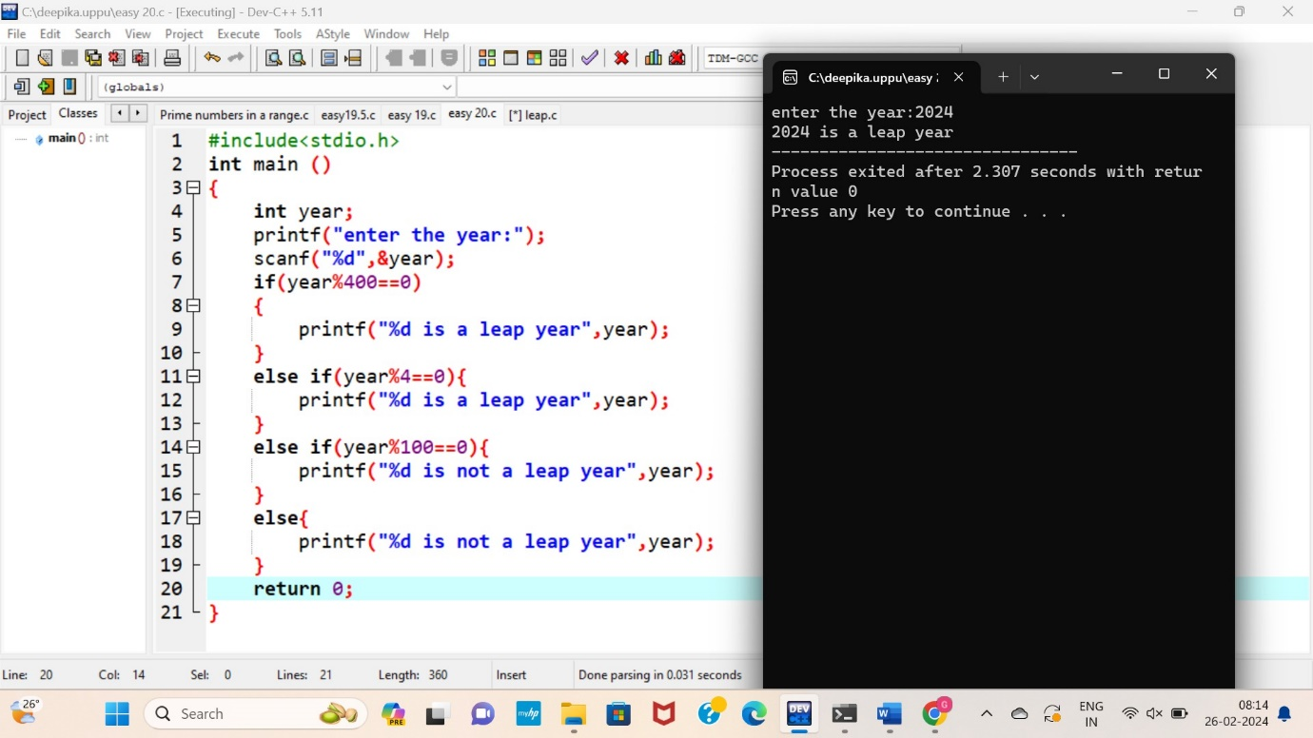

2.Fabinocci series

#include<stdio.h>

int main ()

{

int i,n;

int t1=0,t2=1;

int nextterm=t1+t2;

printf("enter the no of terms:");

scanf("%d",&n);

printf("fabinocci series:%d\n%d\n",t1,t2);

for(i=3;i<=n;i++)

{

t1=t2;

t2=nextterm;

nextterm=t1+t2;

printf("%d\n",nextterm);

}

return 0;

}

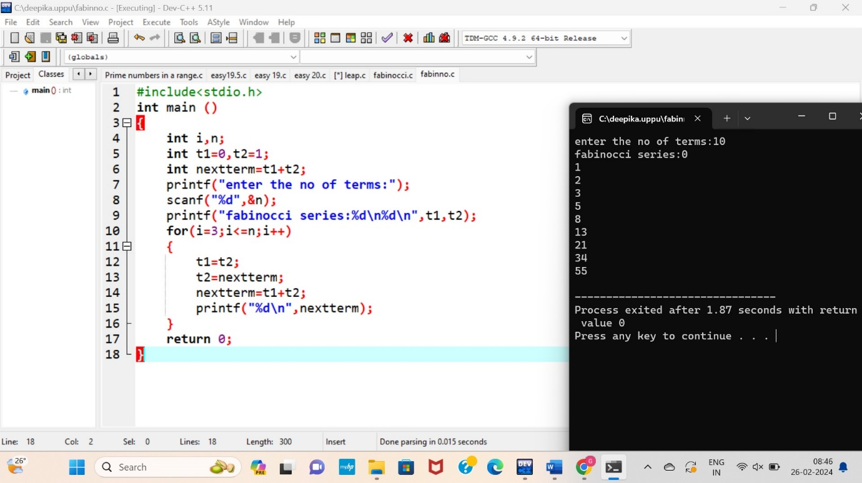

3.factorial

#include<stdio.h>

int main ()

{

int i,n,fact;

printf("enter the value of n:");

scanf("%d",&n);

if(n<0){

printf("factorial does not exsists for a negative number!");

}

else{

for(i=1;i<=n;i++){

fact\*=i;

}

}

printf("factorial=%d",fact);

return 0;

}

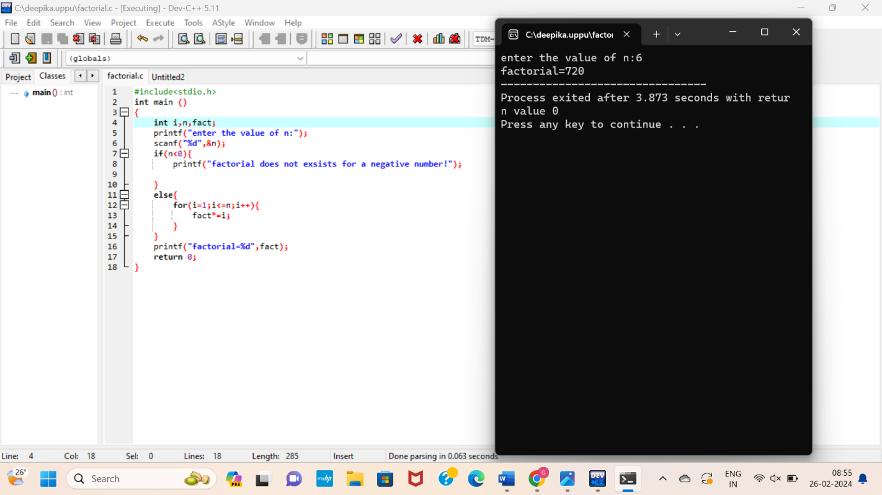

4.floyd’s triangle

#include <stdio.h>

int main() {

int rows, i, j, number = 1;

printf("Enter the number of rows: ");

scanf("%d", &rows);

for (i = 1; i <= rows; i++) {

for (j = 1; j <= i; ++j) {

printf("%d ", number);

++number;

}

printf("\n");

}

return 0;

}

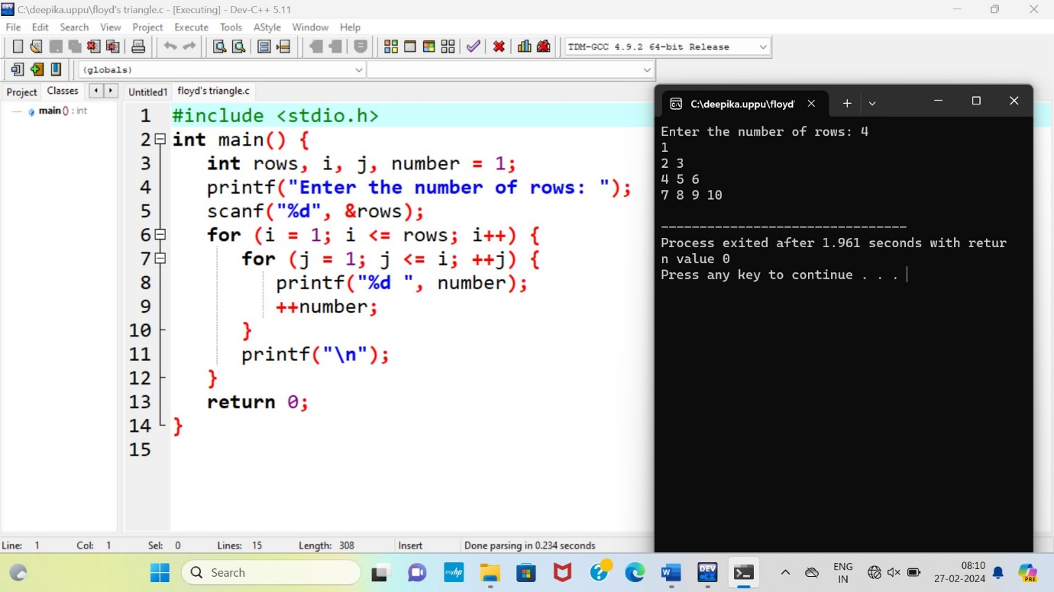

5.pascal triangle

#include <stdio.h>

int main() {

int rows, coef = 1, space, i, j;

printf("Enter the number of rows: ");

scanf("%d", &rows);

for (i = 0; i < rows; i++) {

for (space = 1; space <= rows - i; space++)

printf(" ");

for (j = 0; j <= i; j++) {

if (j == 0 || i == 0)

coef = 1;

else

coef = coef \* (i - j + 1) / j;

printf("%4d", coef);

}

printf("\n");

}

return 0;

}

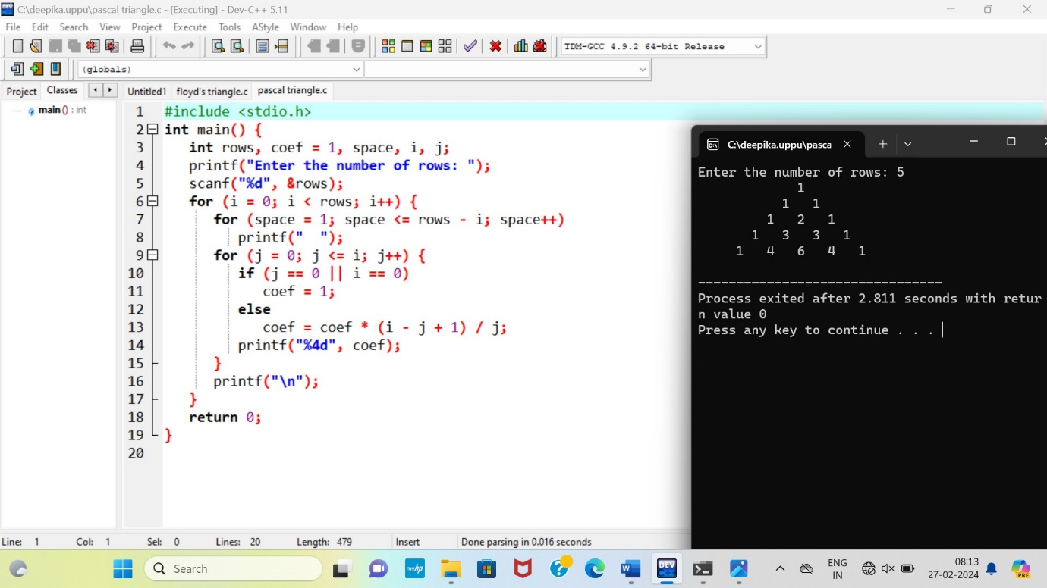

6.diamond star pattern

#include <stdio.h>

int main()

{

int n, c, k;

printf("Enter number of rows\n");

scanf("%d", &n);

for (k = 1; k <= n; k++)

{

for (c = 1; c <= n-k; c++)

printf(" ");

for (c = 1; c <= 2\*k-1; c++)

printf("\*");

printf("\n");

}

for (k = 1; k <= n - 1; k++)

{

for (c = 1; c <= k; c++)

printf(" ");

for (c = 1 ; c <= 2\*(n-k)-1; c++)

printf("\*");

printf("\n");

}

return 0;

}

